Tenda F3--How to make a parental control

If you enable the parental control feature, you can control the access time of the device of your children.

Step 1: Enter the configuration page of your router.

- Open a browser then type “192.168.0.1” into the Address Bar, press Enter. Then enter the password of this page. Tap “Login”.

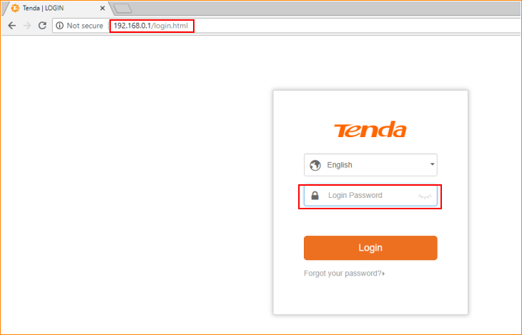

Note: The default password is shown on the bottom of the router. If you have changed it and you also forgot it, see “Forget your password?” below the “Login” button.

- Then the interface will turn into the homepage, tap “Parental Controls”, and then you can see the interface like the picture below.

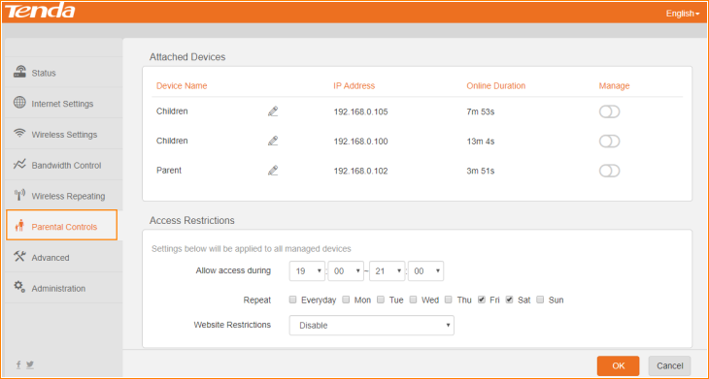

Step2: Make a schedule for the device of your children.

- For example, in this picture, the “Children” device belongs to your kid. Tap the “manage” button to enable them get parental control.

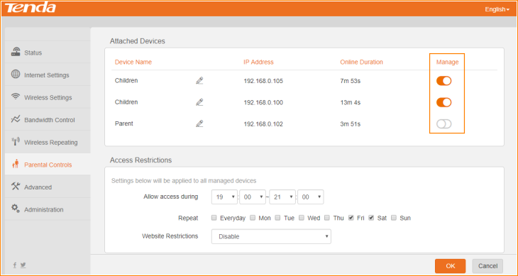

- Configure time schedule, including the day in one week and the time in one day.

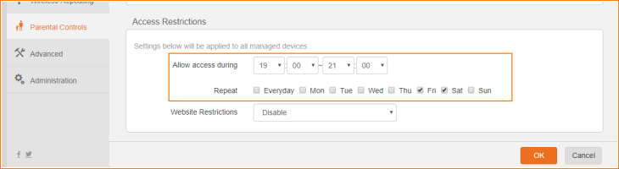

- Configure website Restriction. Tap the “Website Restrictions”, you can see three options in it.

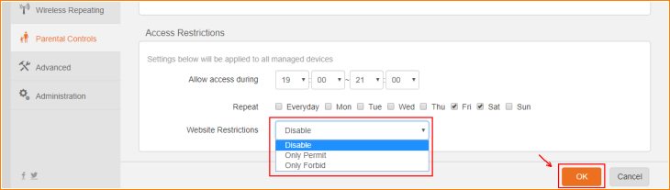

Disable: The device of your children could not access the internet unless it is in the time duration of the schedule configuring in 2.
Only Permit: The device of your children can only access the website you permit unless it is in the time duration of the schedule configuring in 2.
Only Forbid: The device of your children could not access the website you forbid unless it is in the time duration of the schedule configuring in 2.

Note: When you type the Permit and Forbid website, you only need to type the domain name. For example, for www.google.com, you just need to type google.com

- Tap “OK”. Then the device of your children is under your management and their internet behavior would follow the schedule you configure before.

- If you want to remove the device from your schedule, tap “manage” button to remove it. Then type “OK”.

